The Nuclear Model of Electrical Conductivity
This model describes electrical conductivity as a direct result of the nuclear structure of the atom – specifically, how the proton rings are arranged around the axis, and how the axis protons interact with the surrounding fields.
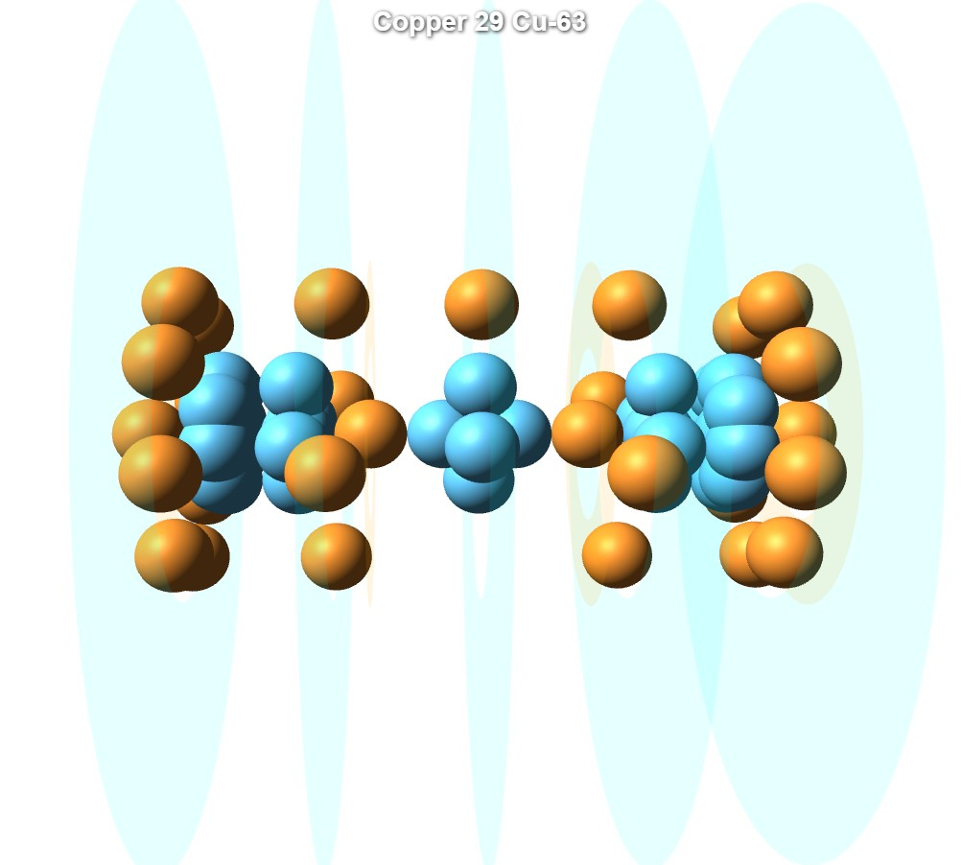

1. Electric Fields in the Nucleus
To understand the concept of nuclear structure and fields, I begin with a hypothetical model of the oxygen atom. In this model, we observe that each proton along the axis produces a field, and so does each ring. The proton ring rotates around the axis, and its field rotates accordingly. The axis protons also have spin, and their field rotates in the opposite direction. This opposite motion cancels out radial influence on the axis, thus maintaining internal stability. The fields from the axis help “stabilize” the ring so it remains perpendicular to the axis. Additional, weaker fields exist — particularly from the spin of the protons in the ring — which will be addressed in a separate paper.
A key insight is that the strength of a material is determined by the intensity of its electric field. Materials with axis protons that separate fields are typically softer.
We note here that based on the nuclear field model, there is an analogy between the energy level and the size of the atom — specifically, the radius of the electric field. The relationship is (R ∝ n²). This means that as we move to higher energy levels, the electric fields expand.
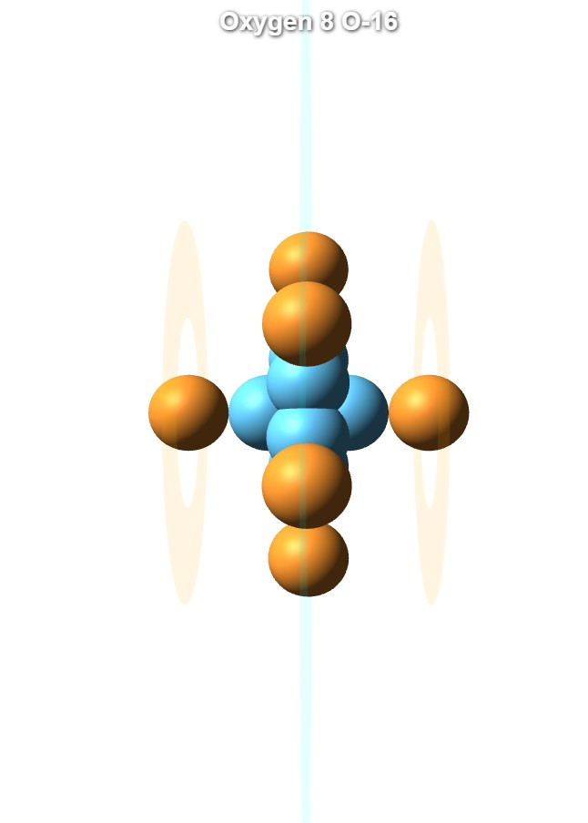
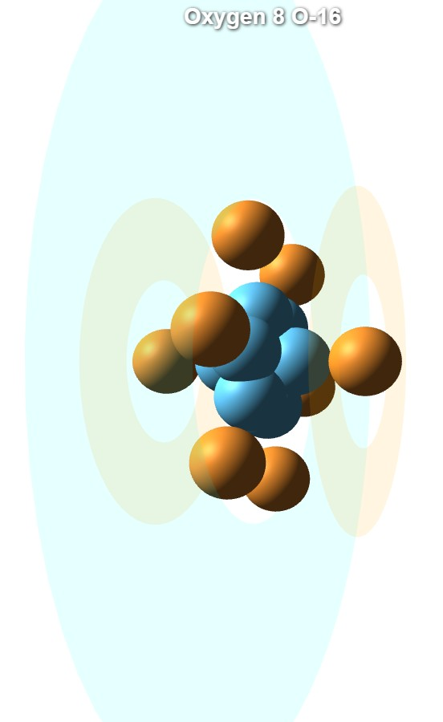

2. Conditions for Conductivity

2.1 Conduction Channel
For electrical conductivity to occur in an atom, there must be a region where the electric potential approaches zero. This region forms between two symmetric and parallel electric fields — such as between two full proton rings. The gap between them constitutes a “conduction channel” in which free electrons can flow without being affected by the field.
There are two types of conduction channels:
- The first type is formed through direct repulsion between protons in adjacent rings. These channels are sensitive to current and collapse easily when the fields expand — leading to overlapping fields. Iron is an example of this, as described later.
- The second type is formed through repulsion from the fields generated by axis protons. This channel remains stable even when the fields expand, and disturbances from current have minimal impact.

2.2 Free Electrons
At the center of the conduction channel, there exists one additional ring — this is where the free electrons reside. The electrons in this ring move inside a region of near-zero potential.
The number of protons (and electrons) in the ring determines the strength of the field holding the electrons. When there is only one electron in the ring, the field is very weak, and the electron can easily be detached and turned into current. As the number of protons increases, the field becomes stronger, making it harder to dislodge electrons.
Additionally, one must consider the ring’s rotational frequency. When there is no synchronization between the frequency of the ring and the frequency of the current, field disturbances arise — which degrade conductivity.
In certain materials with more than one free electron, synchronization may occur between the current and field frequency. In such cases, conductivity can exceed that of copper by a factor of two or even three.

3. The Optimal Conductor – Copper Atom
Copper contains two fully populated outer rings — each with 8 protons. Between them lie two inner rings, each with 4 protons. In the very center, there is a small ring with a single proton. All rings produce fields of equal radius, meaning that rings with fewer protons produce weaker fields. This five-ring symmetric configuration creates a particularly stable field structure and an optimal conduction channel.
The channel’s stability does not rely solely on inter-ring repulsion, but also on the presence of two axis protons — one on each side of the channel — which help stabilize and isolate the field from external disruption.
During conduction, the electron travels through a zone of near-zero potential and is unaffected by the surrounding field. Since there is only one electron in the conduction ring, its bond is weak, enabling free movement — an ideal state for conductivity.
A similar conduction channel structure is found in the silver atom. Like copper, silver features full outer rings and a central channel, allowing free electron flow through a low-potential region. This structural similarity explains why silver exhibits conductivity values comparable to or even slightly higher than copper.

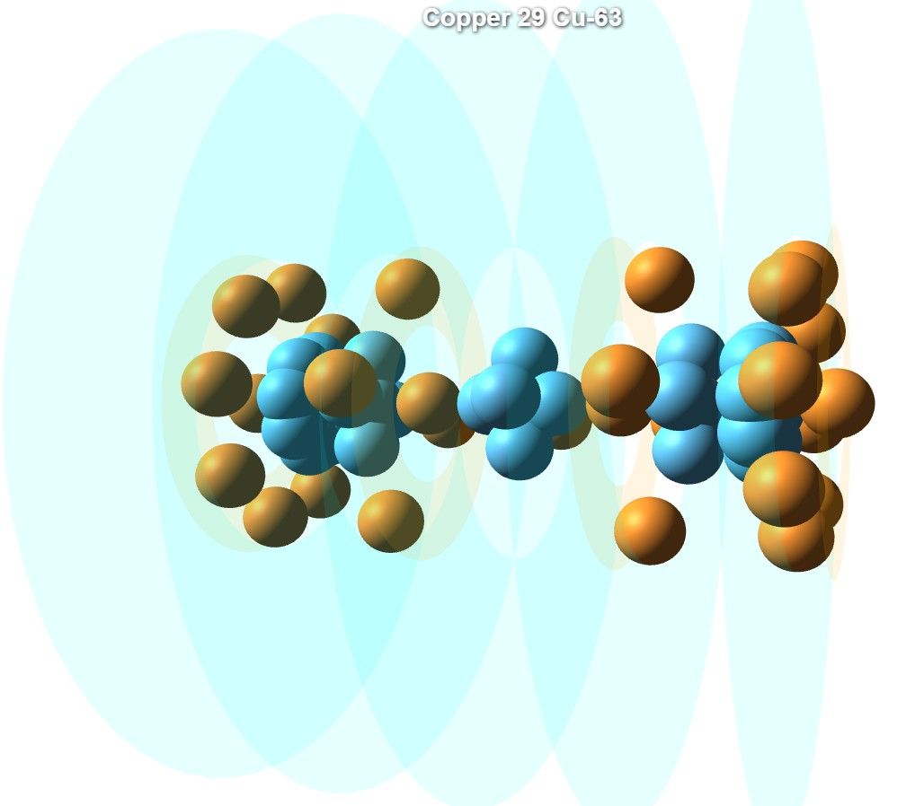

4. The Poor Conductor – Iron

Iron also contains two full rings on the outer sides — each with 8 protons — and two additional inner rings with 4 protons each. However, it lacks a dedicated conduction ring where free electrons can reside.

As a result, even though a channel exists, iron conducts poorly. Current must be carried by forcibly detaching electrons from the inner rings, causing field disruption and damage to the conduction channel.
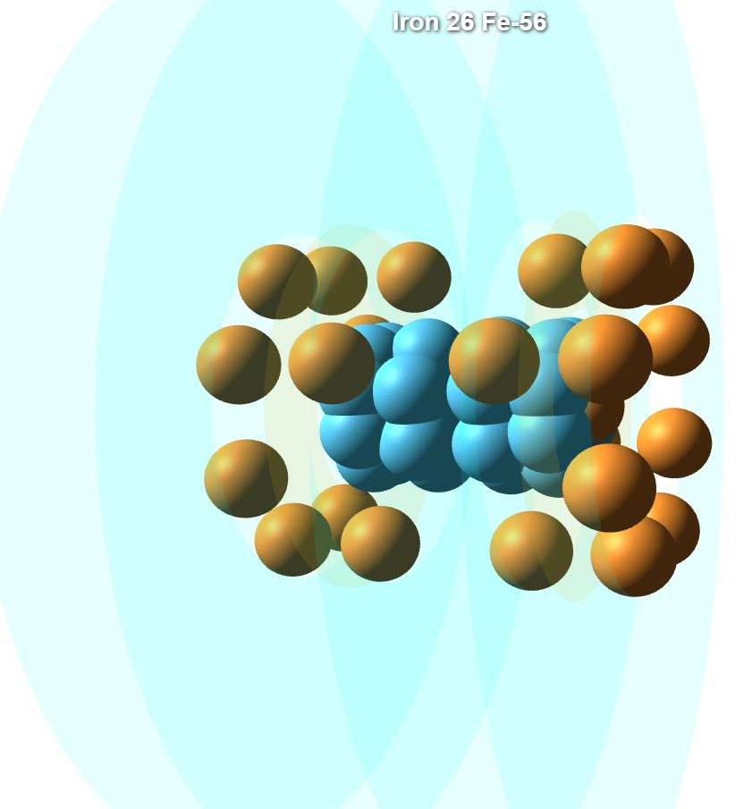
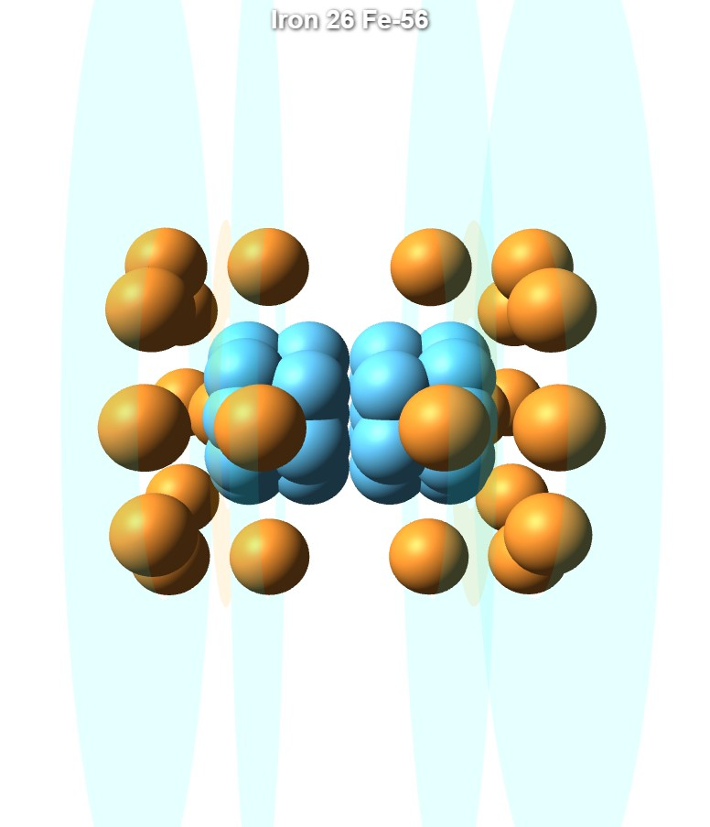

5. Conductivity at High Temperatures
In copper, the conduction channel remains stable even at high temperatures due to the axis protons that push the outer rings apart. As long as this channel remains intact, electrons can flow freely and the material continues to conduct.
However, when temperature rises, the energy level increases:
- The electric fields expand.
- The field generated by ring protons weakens.
- The proton spin — responsible for field generation — saturates, limiting field spread.
Once the field expands beyond what the spin can support, the influence of the axis protons disappears. The separation between outer rings is then maintained only by ring-to-ring repulsion, making the channel more fragile and significantly degrading conductivity.

6. Superconductivity
Superconductivity occurs when the following conditions are met:
- A perfect conduction channel forms between parallel electrical fields.
- Electrons move through a region where the potential is nearly zero.
- The influence of electrons on the protons generating the field is minimal or null.
In this state, the channel is unaffected by current flow, allowing resistance-free conduction.
However, reaching this state requires precise balance:
- At high temperatures, the fields expand and current disturbance increases, harming conduction.
- At extremely low temperatures, the overall fields shrink so much that electrons get too close to the axis — again interfering with proton structure.
Thus, the goal is not to reach the lowest temperature possible, but to find the precise critical temperature where:
- The field is strong enough to separate the rings.
- The gap between fields is stable.
- The electron moves through a location where its influence on nuclear structure is null.
This critical temperature varies between materials and is key to achieving practical superconductivity.

